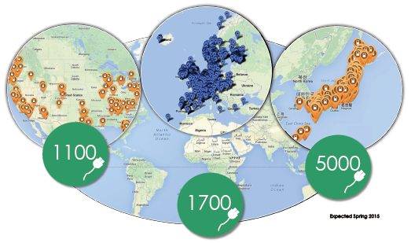

CHAdeMO

*CHAdeMO should get ready for the war to come on the standardization of the fast charging station. Originally leading in the domain, its position could be endangered by other standards. What makes this giant having feet of clay?*

CHAdeMO is an association promoting a standard for the DC fast charging station. Its aims at establishing a dense network of fast charging stations worldwide, because it considers that this is the only way to overcome the range anxiety effect, the fear of drivers to run out of battery in a desert without charging stations. With a technology permitting to charge every electric vehicle up to 80% of its battery capacity in 30 minutes, CHAdeMO recommends, according to the Japanese origin of its name, to drink a cup of tea meantime.

Consisting today of more than 341 companies from more than 38 countries, its early development was relatively fast. Indeed, this champion was originally a consortium of all the best Japanese industries that could have a role to play in the electric vehicle industry: TEPCO, which was the first to start a R&D program on charging stations in 2005; but also automotive companies like Toyota and Nissan, as well as battery and energy companies. Together, these companies founded the association in 2009. At the end of 2010, the first electric vehicle compatible with the standard was launched in the market: the Nissan Leaf.

Quickly, things accelerated. Backed by the Japanese government, which gave subsidies for R&D for the performant companies, a dense network of charging stations emerged in Japan; after that came the turn of Europe and the United States to electric charging. Nowadays, more than 7,000 CHAdeMO charging stations are connected to the grid. The sale of electric vehicles compatible to CHAdeMO standard has also risen sharply: between 2010 and 2014, 368,000 electrical vehicles were sold, among them 80% are fast chargeable. 50% of the electric vehicle car market is compatible with CHAdeMO standard.

At the same time, CHAdeMO companies share their resources to impose their standard on the market, gathering security issues, a maximal voltage of 50kW, and communication channels between the battery and the charger. The technology is still flexible to adapt to the rapid changes in the market. The specifications are improved every year through various workshops. Nowadays, many car manufacturers produce cars that can use CHAdeMO plug. These efforts finally resulted in the recognition of CHAdeMO as an international standard and as a European standard.

Its recognition as an official standard is a great advantage for all the companies participating in the CHAdeMO association: they get a guarantee that their technology will be used in the following years. Instead of fighting to impose their standard, which would be a barrier to the rapid development of the market, they need to convince the consumer in terms of technical performance and price. With the obstacles to the competition being alleviated, the race for innovation is very fierce: more than 50 companies actually manufacture different DC charging stations with the standard CHAdeMO, and the technology is improving at a fast pace. The company Fuji recently launched a low cost charger: by lowering the voltage to 20kW, it makes the usage price go down with an increase in charging time of less than 7 extra minutes. Inevitably, this will pull the prices in the market down.

Western car manufacturers, outpaced in this first round, tried to win the second one by establishing their own competitive standard, Combo. Developed by the biggest automotive manufacturers, such as BMW, Volkswagen, or General Motors, this initiative is an attempt to catch up the lost time against the Japanese corporations. Although there are still only a few cars compatible with Combo charger, Combo managed to be certified as a standard in the US and in Europe. What’s more, all public DC fast charging station in Europe should necessarily be equipped with a Combo plug from 2017, something which is not the case for CHAdeMO.

Still, due to the fact that many components are common between the two standards, many European manufacturers have responded by proposing two plugs in their charging station: one Combo, and one CHAdeMO, with an extra cost of less than 5 to 10% of the total charger price. Consequently, every major stakeholder in the European electric vehicle market finds its own interest: the companies following one of the two standards because they will be well represented in the charger network; the European Union because of the healthy competition environment it managed to provide to the electric vehicle market by permitting the two standards to coexist; and the consumer that can buy an electric vehicle without the fear that the standard they chose will be out of the market the next year.

Thanks to the massive presence of CHAdeMO in the market, both in terms of already existing infrastructure and the wide range of compatible cars, it can not be ignored and has still an important role to play. But will we be able to come to the same conclusion in 10 years? When the biggest Western manufacturers have caught up and proposed competitive electric vehicles, it is not guaranteed that consumers will not massively shift back to their favorite brands from the time of petrol cars. For Westerners these brands are more likely to be German than Japanese. If we add the fact that the Combo charger network will surely be extensively developed due to the European commission’s decision, it is possible that CHAdeMO will be phased out. What’s more, the Fukushima accident has slowed down the dynamism of TEPCO, the leading company in CHAdeMO’s standard and research and publication of new patents in the industry

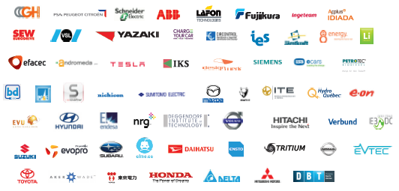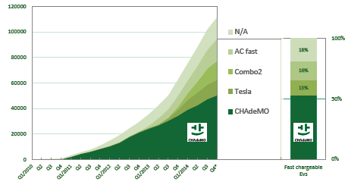



This case clearly shows that the battle of standardization is not over in the market of charging station. Even if CHAdeMO has by far been the fastest to impose its standard, and has done it in a very organized way, the pie is foreseen to be too large for other car manufacturers to ignore it. The coexistence of both the CHAdeMO and Combo standards makes the competition environment in the European Union quite healthy for the moment, but anyone that wants to tap the market should be aware of the risk of putting all its eggs in one basket. Although CHAdeMO is leading the race, the emergence of Combo, and even Tesla supercharger, is of such strength that all the options should be kept open for the moment.

**Note : above is only as a reference for me to check the visual. It should not be considered as the final version of the article, which is in the article document. If the two images on the bottom right**

**Below are the quotes and figures :**

**Quotes:**

**50% of the electric vehicle car market is compatible with CHAdeMO standard**.

**These efforts finally resulted in the recognition of CHAdeMO as an international and European standard**

**((all public DC fast charging station in Europe should necessarily be equipped with a Combo plug from 2017)) (if the one before does not fit)**

**Figures:**

**>50 CHAdeMO chargers**

**Competition with Combo**